# **CRM Application for Jewel Management**

| **Date** | **28-06-2025** |
| --- | --- |
| **Team Id** | LTVIP2025TMID31256 |
| **Project Name** | **CRM Application for Jewel Management** |
| **College Name** | **Ideal Institute Of Technology** |

**TEAM MEMBERS**

* **Team Member: Mosa Dhanush**

**Email:**[**mosamani35@gmail.com**](mailto:mosamani35@gmail.com)

**Introduction**

**A CRM (Customer Relationship Management) application for jewel management is a specialized software designed to streamline customer interactions, sales tracking, inventory management, and after-sales services in the jewelry industry. It empowers jewelry businesses to deliver personalized customer experiences while efficiently managing operations from showroom to delivery.**

### **Key Features**

* **Customer Insights: Track purchase history, preferences, and special occasions to offer tailored recommendations.**
* **Lead & Sales Management: Manage inquiries, convert leads, and monitor sales performance with automated follow-ups.**
* **Inventory Integration: Sync inventory with customer orders in real time, ensuring accurate stock levels and order processing.**
* **IDEATION PHASE**

**Brainstorm & Idea Prioritization**

**Brainstorm & Idea Prioritization Template:**

Brainstorming encourages a collaborative environment where developers, business analysts, and end-users contribute creative ideas to enhance CRM capabilities specific to jewel management. The goal is to generate innovative and actionable ideas that streamline customer engagement, order tracking, and inventory handling—leading to a polished CRM solution tailored for jewelry retail and service.

**Step-1: Team Gathering, Collaboration and Select the Problem Statement**

**Objective:** Assemble a cross-functional team and define the core problem areas in jewel business CRM systems.

**Problem Statement:** Current CRM systems used by jewel businesses lack tailored features for managing personalized customer interactions, tracking high-value inventory, and automating service and order workflows, resulting in customer dissatisfaction and operational inefficiencies.

**Activities:**

* Gather team members: Developers, UI/UX designers, jewel sales experts, business analysts.
* Use collaboration tools like Miro or Figma for remote ideation.
* Define scope: Focus on customer profile management, purchase history, custom order tracking, and loyalty programs.
* Assign roles: A facilitator to drive discussions and a scribe to document key inputs.

**Step-2: Brainstorm, Idea Listing and Grouping**

**Objective:** Generate and categorize a wide range of ideas to address the unique CRM needs of a jewel management system.

**Process:**

* Conduct a 20-minute brainstorming session encouraging creative and specific ideas.
* Capture ideas using sticky notes or a virtual whiteboard.
* Group ideas under the following categories:

**Feature Categories:**

1. **Customer Relationship Management:**
   * Loyalty program integration
   * Personalized product recommendations
   * Anniversary and festival reminders
2. **Inventory & Order Management:**
   * Real-time inventory tracking of high-value items
   * Custom order tracking (design, status, delivery)
   * Barcode/RFID-based stock updates
3. **Sales & Support Automation:**
   * AI chatbots for customer queries
   * Auto-generated quotations and invoices
   * After-sale service workflows
4. **Analytics & Reports:**
   * Customer purchase trends
   * Stock movement reports
   * ROI on marketing campaigns

**Step-3: Idea Prioritization**

**Objective:** Rank the generated ideas based on business impact, ease of development, and cost.

**Process:**

* Use a prioritization matrix (Impact vs. Effort or Cost vs. Value).

## **📊 Developer Pictograph: CRM for Jewel Management**

### **🤔 Think & Feel:**

* **Robust & Scalable CRM: 💪 Wants to build a strong, future-proof system.**
* **Integration Concerns: 🔗 Worried about connecting with existing POS (Point of Sale) and ERP (Enterprise Resource Planning) systems.**

### **👂 Hear:**

* **Jewelers' Needs: 🚀 Feedback for simpler, faster systems.**
* **Customer Demands: 🔒 Requests for personalization and secure data handling.**

### **👀 See:**

* **Competitor Apps: 💅 Slick interfaces but weak backend integration.**
* **Mobile CRM Trend: 📱 Growing use of mobile solutions in luxury retail.**

### **🗣️ Say & Do:**

* **Code Quality: ✍️ Develop secure, efficient, and modular code.**
* **Rigorous Testing: 🧪 Test features thoroughly to prevent live bugs.**

**REQUIREMENT ANALYSIS PHASE**

* **Solution Requirements**

## **✅ Solution Requirements**

### **Functional Requirements**

1. **Customer Profile Management**
   * Create and update customer records.
   * Maintain purchase history and preferences.
   * Track birthdays, anniversaries, and style interests.
2. **Jewelry Order Management**
   * Create, update, and track standard and custom jewelry orders.
   * Upload design images and specifications.
   * Notify customers at key stages: design approval, production, ready for pickup/delivery.
3. **Inventory Management**
   * Track stock levels of gold, diamonds, and finished products.
   * Alert for low-stock or high-demand items.
   * RFID/barcode scanning for physical tracking.
4. **Sales & Billing**
   * Generate quotations and invoices.
   * Apply discounts, taxes, and loyalty points.
   * Integration with payment gateways.
5. **Loyalty & Rewards System**
   * Accrue and redeem points per purchase.
   * Tiered customer levels (e.g., Silver, Gold, Platinum).
   * Personalized offers based on loyalty data.
6. **Customer Interaction & Communication**
   * Automated SMS/Email notifications for order progress and promotions.
   * Festival and occasion greetings.
   * Feedback collection after sales.
7. **Dashboard & Reporting**
   * Sales reports by date, product, or customer segment.
   * Inventory movement and reorder reports.
   * Customer behavior analytics.
8. **Mobile & Web Application Interface**
   * Responsive user interface for in-store and customer use.
   * Digital receipts, designs, and catalog access.
   * Real-time notifications and customer service chatbot.

**6. Mobile App / Field Technician Interface**

* Offline capability.
* Work order checklist, photo upload, digital signatures.
* Navigation assistance.
* Ability to update status, log time and materials.

**7. Customer Communication**

* Appointment confirmations, reminders via SMS/email.
* Real-time ETA tracking for customers.
* Feedback collection after service.

**8. Asset & Equipment Management**

* Maintain asset service history.
* Track warranties and contracts.
* Monitor IoT-connected devices for proactive service.

**9. Analytics & Reporting**

* SLA compliance, first-time fix rate (FTFR), travel time, technician utilization.
* Real-time dashboards for dispatchers and management.
* Historical data trends for predictive maintenance.

### **🔒 Non-Functional Requirements**

* **Performance**
  + **Low latency interactions, especially during peak shopping seasons.**
  + **Fast response times on web and mobile platforms.**
* **Security**
  + **Role-based access (admin, sales rep, manager).**
  + **Data encryption for sensitive customer and transaction data.**
* **Scalability**
  + **Support for multi-branch jewelry chains.**
  + **Cloud deployment for regional/global scaling.**
* **Integration**
  + **POS and ERP systems (e.g., Tally, Zoho).**
  + **Payment gateways (Razorpay, Paytm, Stripe).**
  + **Email/SMS service providers.**
* **Configurability**
  + **Custom workflows for order approval and production.**
  + **Dynamic customer segmentation for marketing.**
* **Usability**
  + **Intuitive UI for both store employees and customers.**
  + **Multi-language support for diverse customer base.**
* **Availability**
  + **99.9% uptime with auto-failover.**
  + **Scheduled backups and disaster recovery.**

**PROJECT DESIGN PHASE**

**🔍 Problem-Solution Fit**

#### **Problem Statement:**

**Jewel businesses face several inefficiencies and operational challenges due to:**

**Manual tracking of customer purchases, leading to loss of data and poor customer experience.**

**No centralized system for managing customer preferences, purchase history, and service records.**

**Difficulty in following up with potential buyers and managing leads.**

**No automation for promotions, loyalty programs, or personalized offers.**

**Inventory mismanagement due to lack of integration with CRM.**

**Inadequate analytics on sales trends, customer lifetime value, and staff performa**

**🎯 Goal:**

**To provide an intelligent CRM solution that enables jewel businesses to track customer relationships, personalize experiences, manage inventory links, and analyze business insights for sales growth and customer loyalty.**

**🧩 Solution Components**

**Customer Relationship Management Core**

**Centralized customer database**

**Lifetime purchase history, preferences, and birthday/anniversary alerts**

**Lead Management & Automation**

**Capture walk-in leads, website inquiries, social leads**

**Assign sales reps automatically**

**Follow-up workflows and task management**

**Promotions & Loyalty Program**

**Automated discounts for returning customers**

**Tiered loyalty program with rewards tracking**

**Personalized offers through SMS/WhatsApp/email**

**Sales & Billing Integration**

**Invoice generation with barcode/item tagging**

**🛠️ Technology Stack**

| **Layer** | **Technology** |
| --- | --- |
| **Frontend** | **React.js (Web), Flutter (Mobile App)** |
| **Backend** | **Node.js, Spring Boot** |
| **Database** | **MySQL, MongoDB** |
| **Integration** | **REST APIs, Twilio (SMS), WhatsApp Cloud API** |
| **Cloud/DevOps** | **AWS, Firebase, Docker, GitHub Actions** |

**🚀 Deployment Plan (Phased)**

**Phase 1 – Core CRM Deployment**

**Launch customer database, billing module, and lead management**

**Phase 2 – Loyalty & Integration**

**Add promotional engine, loyalty system, and POS/Inventory integration**

**Phase 3 – Advanced Insights**

**Enable AI-based insights, segmentation, and predictive analytics**

**🏗️ Solution Architecture: JewelCRM**

**JewelCRM is a modular, cloud-based CRM tailored for jewel businesses to manage the full customer lifecycle. It centralizes customer data, automates communication, tracks loyalty, and connects seamlessly with sales and inventory systems.**

**Key components include:**

**A mobile-friendly CRM portal for staff**

**A loyalty engine and promotional manager**

**Real-time sync with stock data**

**Sales forecasting and churn prediction**

**Secure access with audit logs and backup**

**🥇 Project Objectives:**

**🔍 Organize Customer Data  
 Digitize and centralize all customer interactions, preferences, and sales for better personalization and service.**

**💬 Engage Customers Smartly  
 Automated personalized messages and offers to improve engagement, conversion, and repeat sales.**

**📈 Boost Revenue and Loyalty  
 Enable data-driven upselling, loyalty incentives, and personalized recommendations.**

**🔄 Synchronize with Inventory & Billing  
 Reduce manual errors and mismatches by linking CRM to stock and billing in real-time.**

**📊 Drive Data-Driven Decisions  
 Leverage analytics for customer segmentation, high-value buyer identification, and trend tracking.**

**✅ Ensure Seamless Operations  
 Automate everyday tasks, ensure timely follow-ups, and streamline the customer journey from first contact to repeat purchase.**

# 

# PROJECT DEVELOPMENT PHASE

Introduction:

The **development phase** of a CRM application tailored for jewel management is a critical stage where technical ideas are transformed into a functional system. This phase focuses on building the core architecture, integrating features, and ensuring the system meets both business needs and user expectations specific to the jewelry domain.

.

## **.Created developer org and explored platform features**

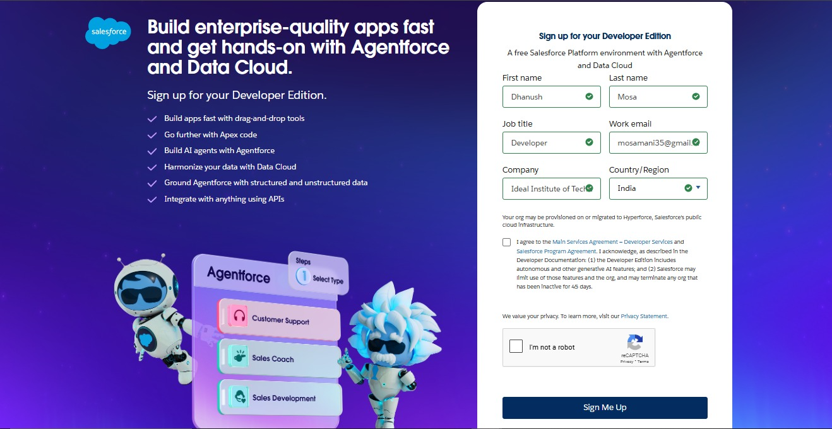

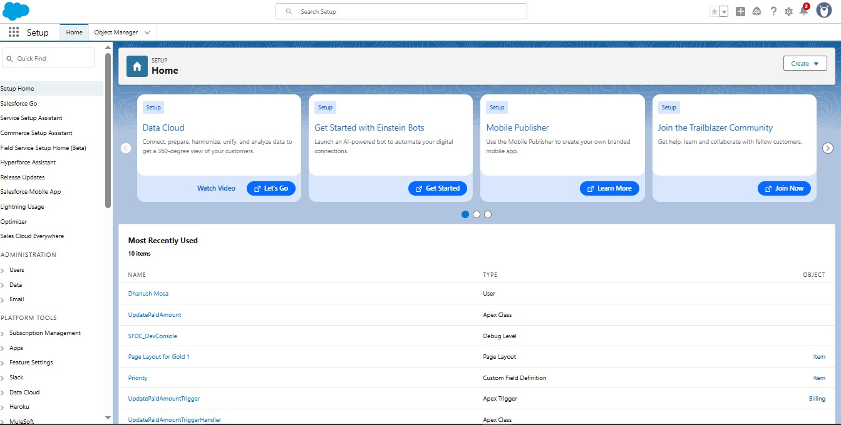

* **Created custom objects:Jewel Customer,Customer Order,Price,Billing,item**

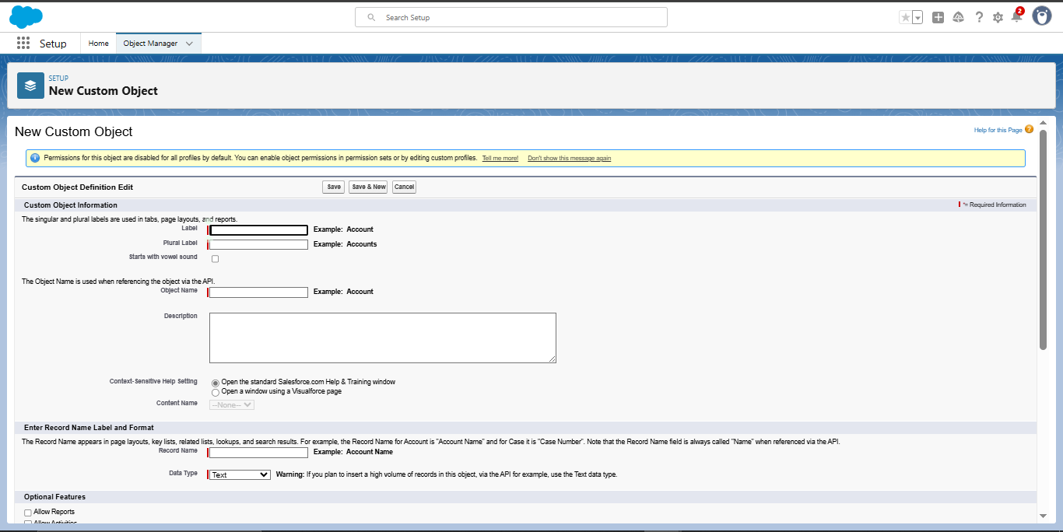

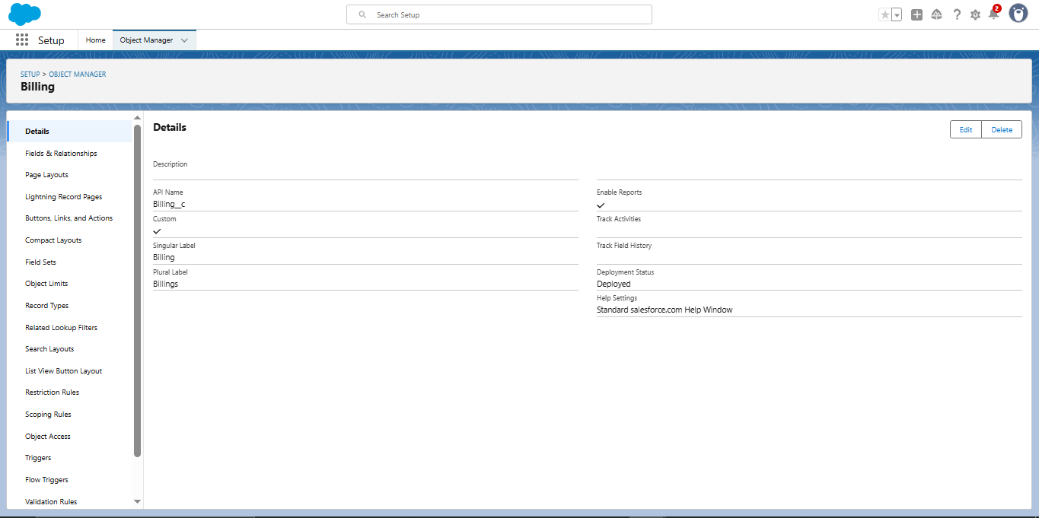

* **Created tabs for the custom objects**

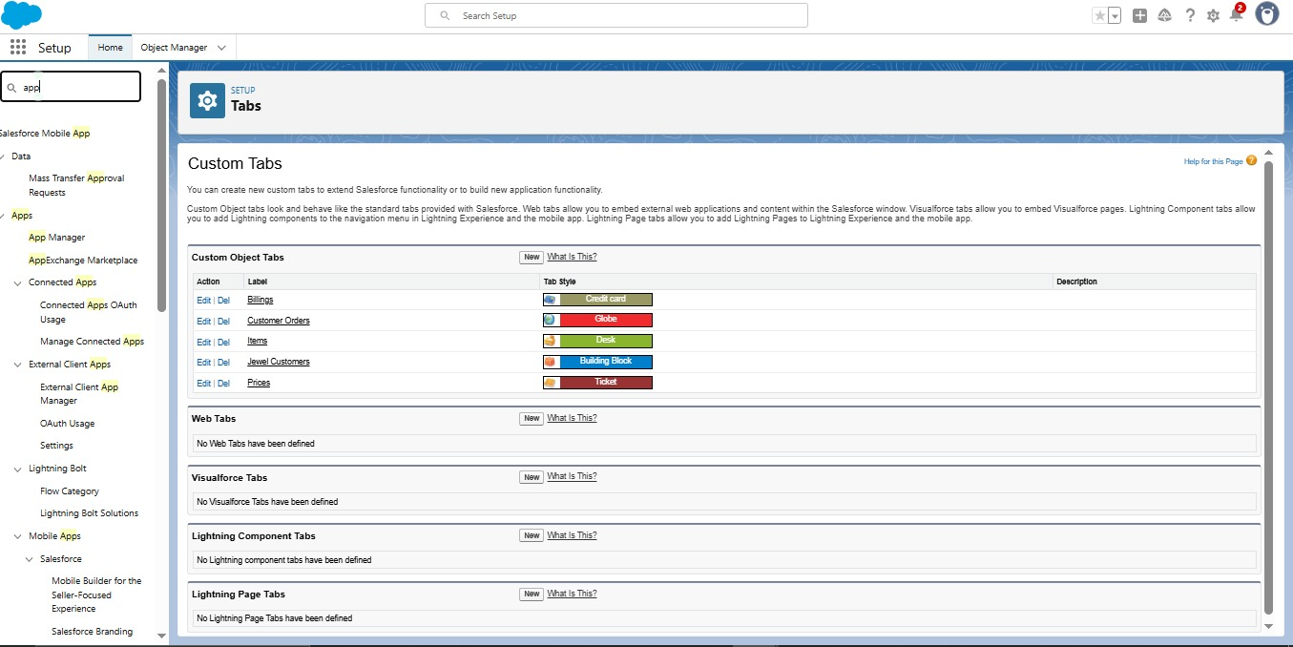

* **Developed a Lightning App**

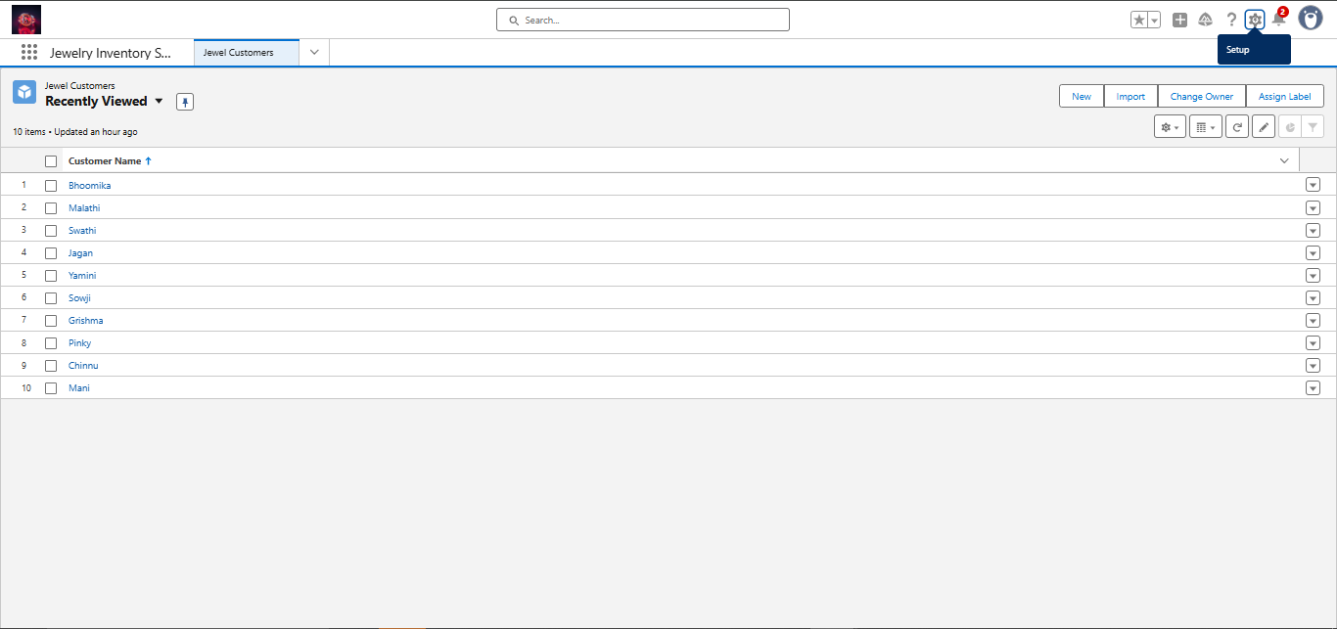

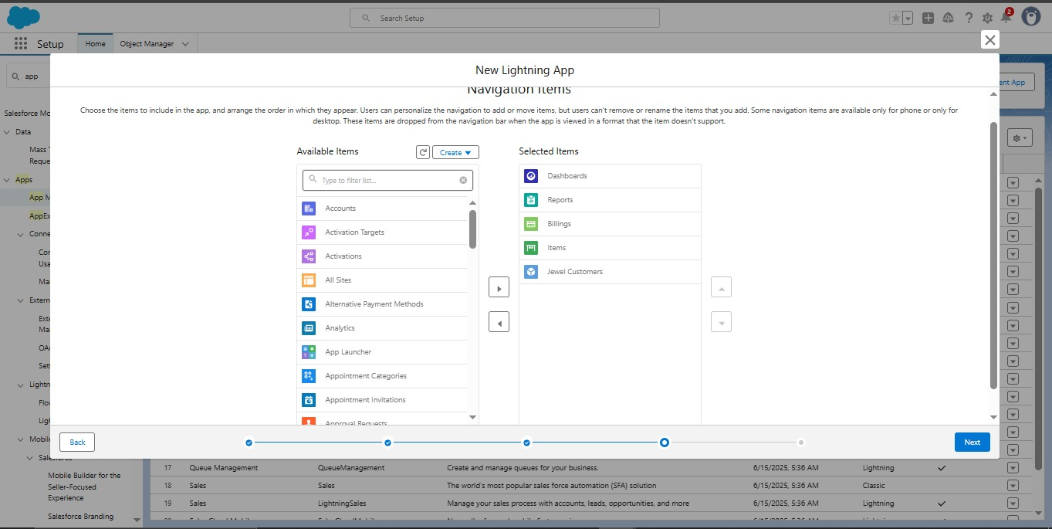

* **Create Fields for the objects.**

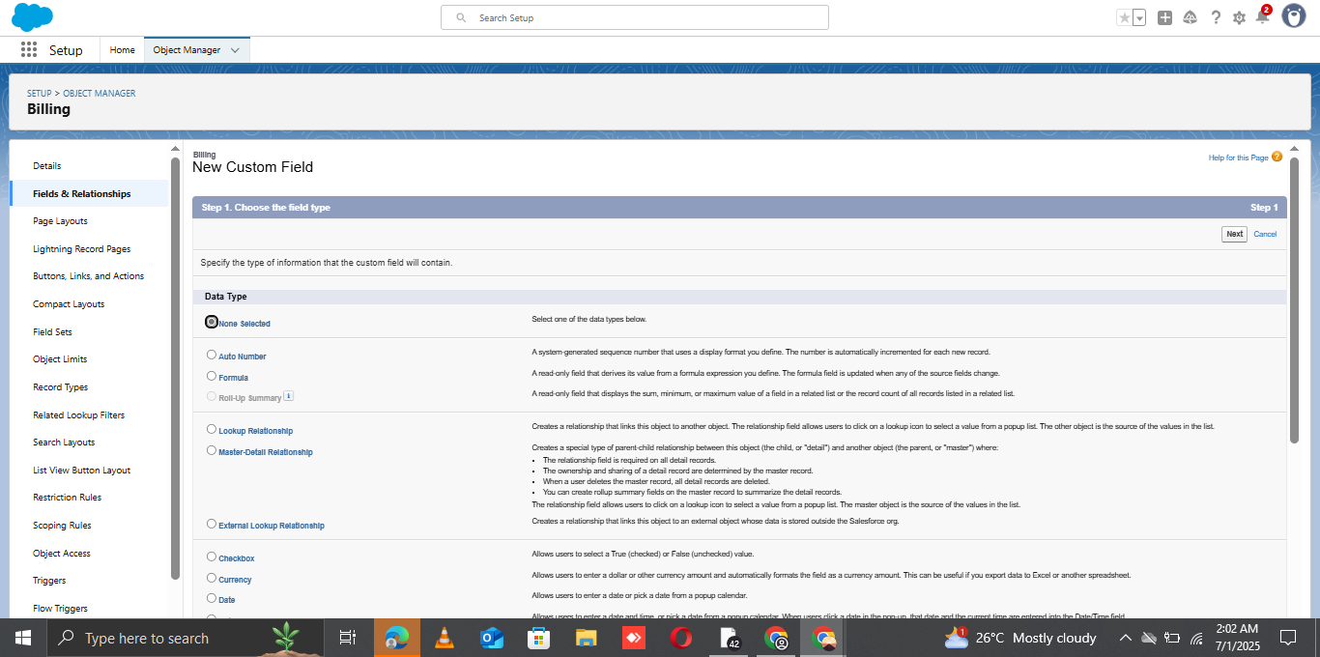

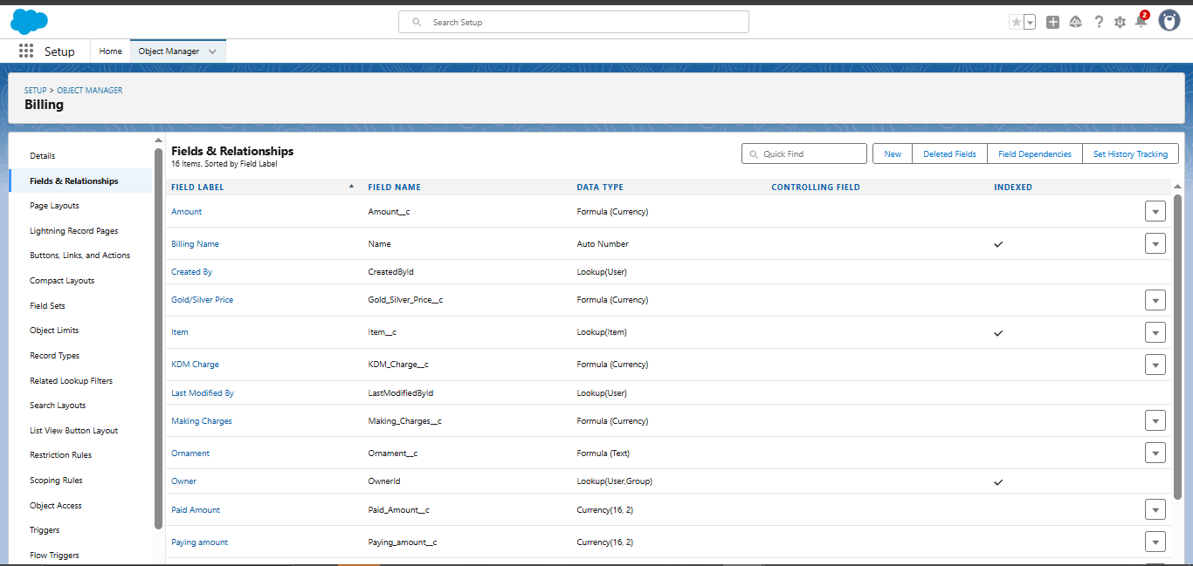

* **Schema Builder**
* The **Schema Builder** was used to visually design and manage the data model for the Field Service WorkOrder Optimization system in Salesforce. It provided a drag-and-drop interface to create and modify custom objects, fields, and relationships without needing code.

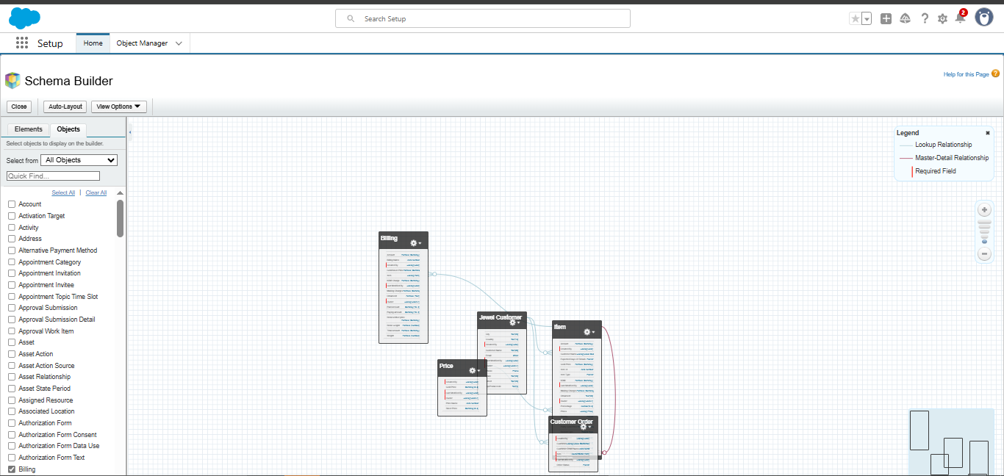

* **Created a Validation Rule for the Object**

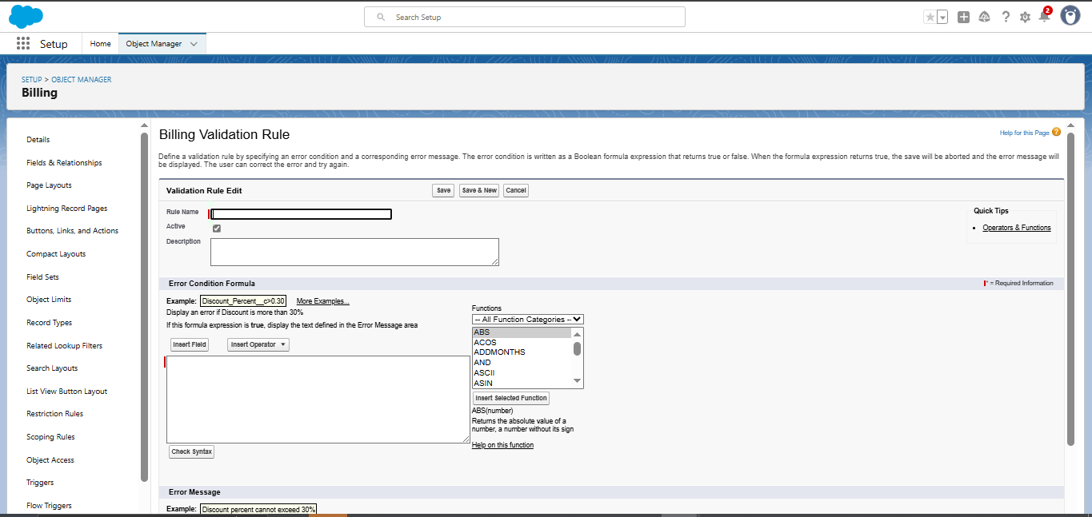

* **Created a profile**

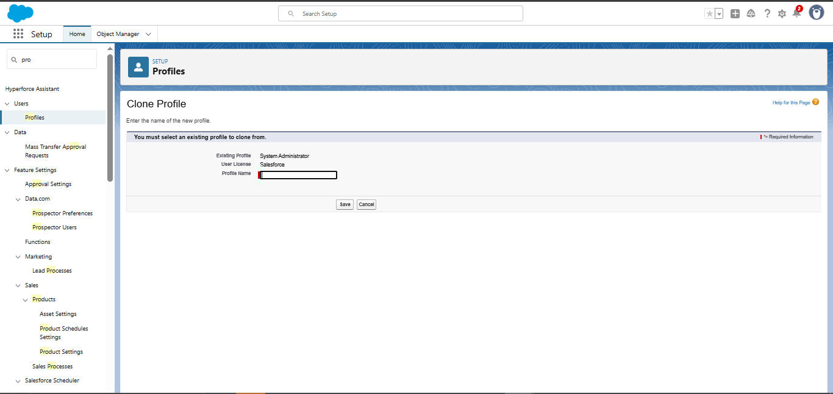

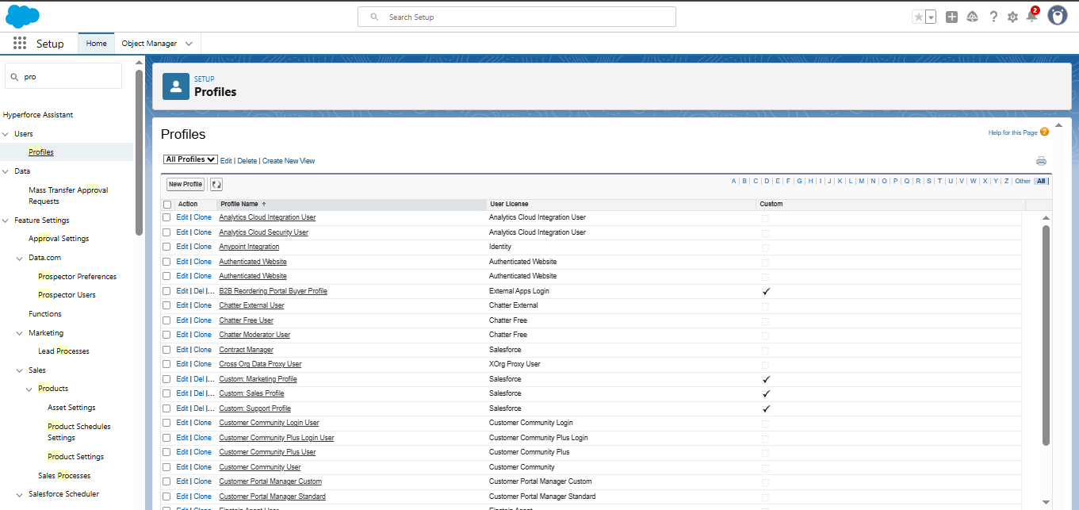

* **Create Goldsmith role**

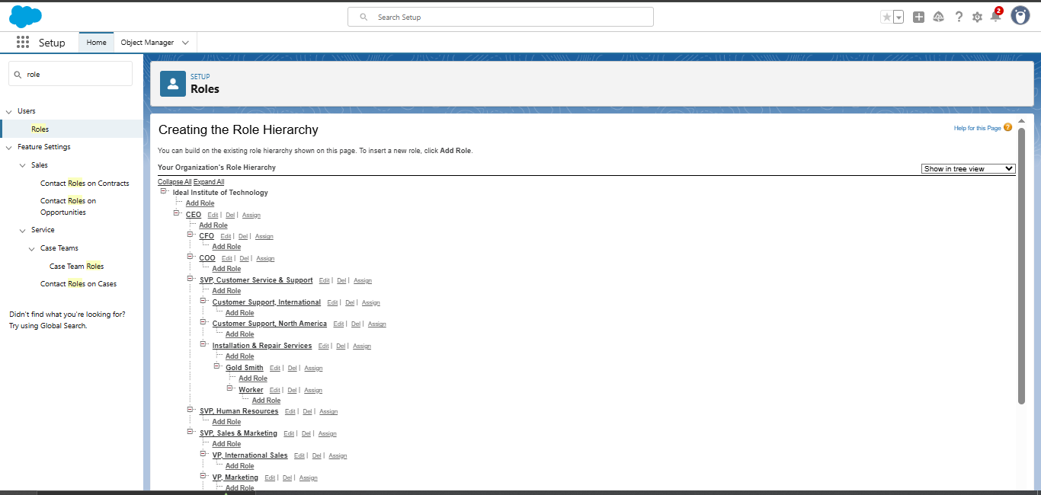

* **Created Users**

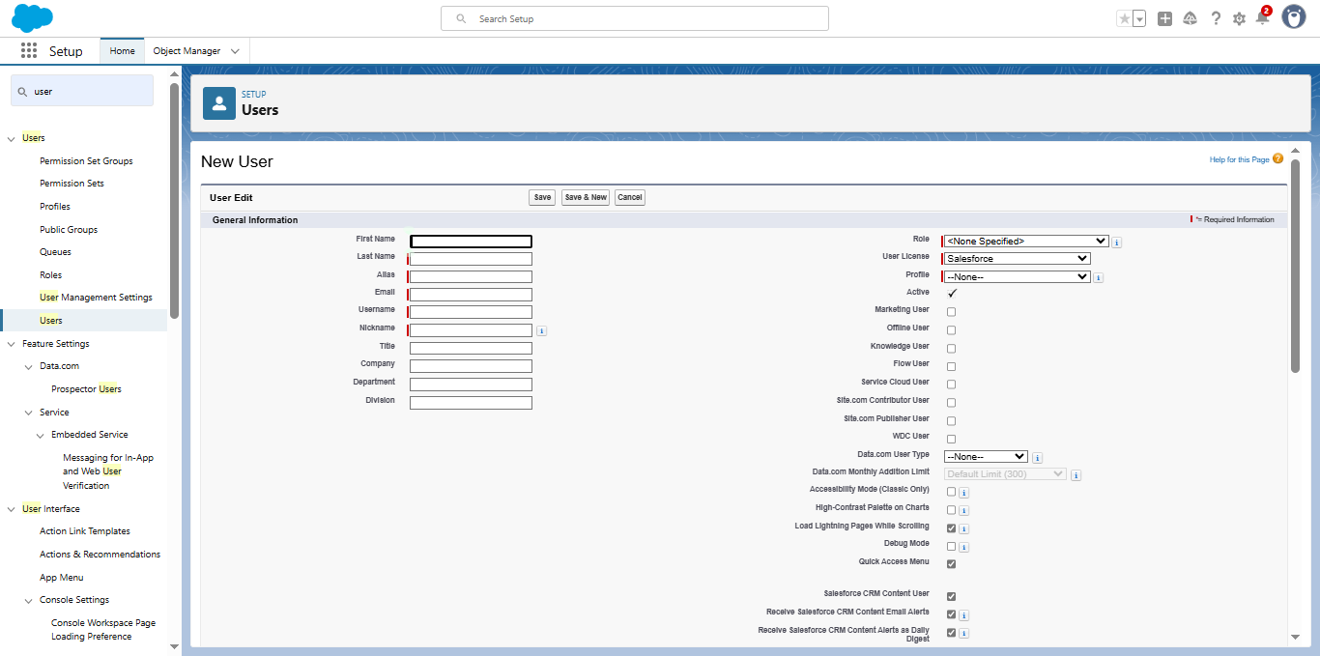

* **Create Page Layouts**

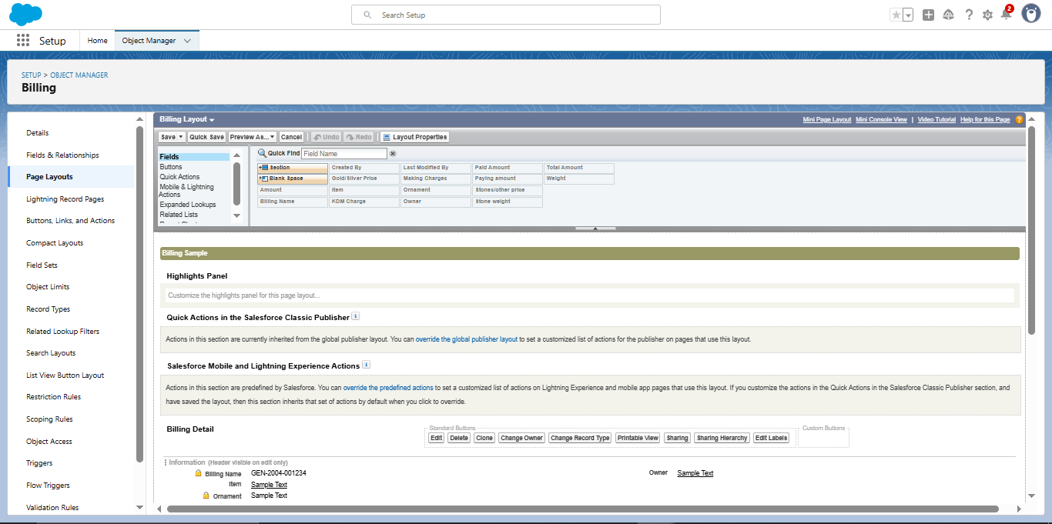

* **Create Record Type**

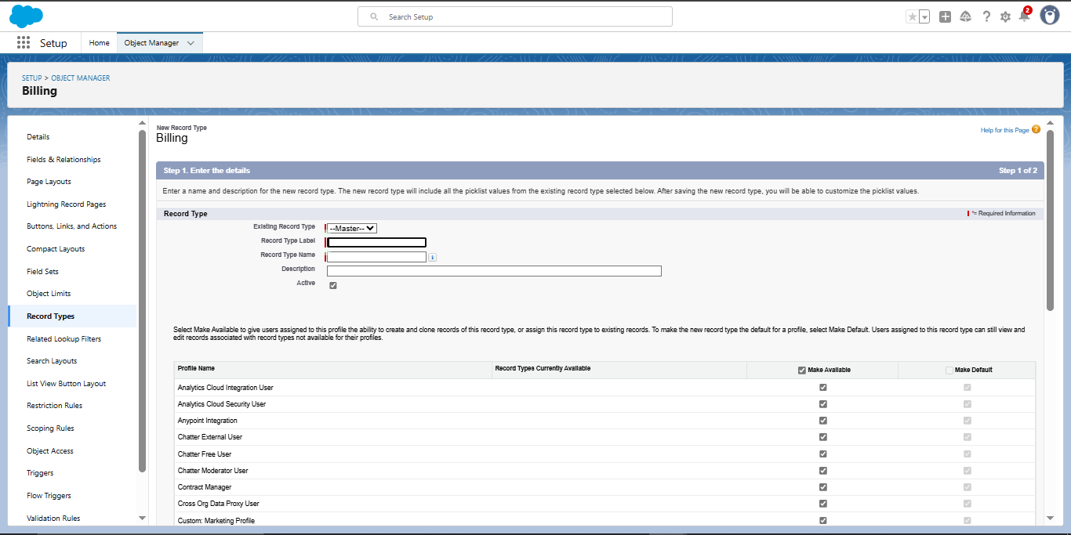

* **Create Permission Set**

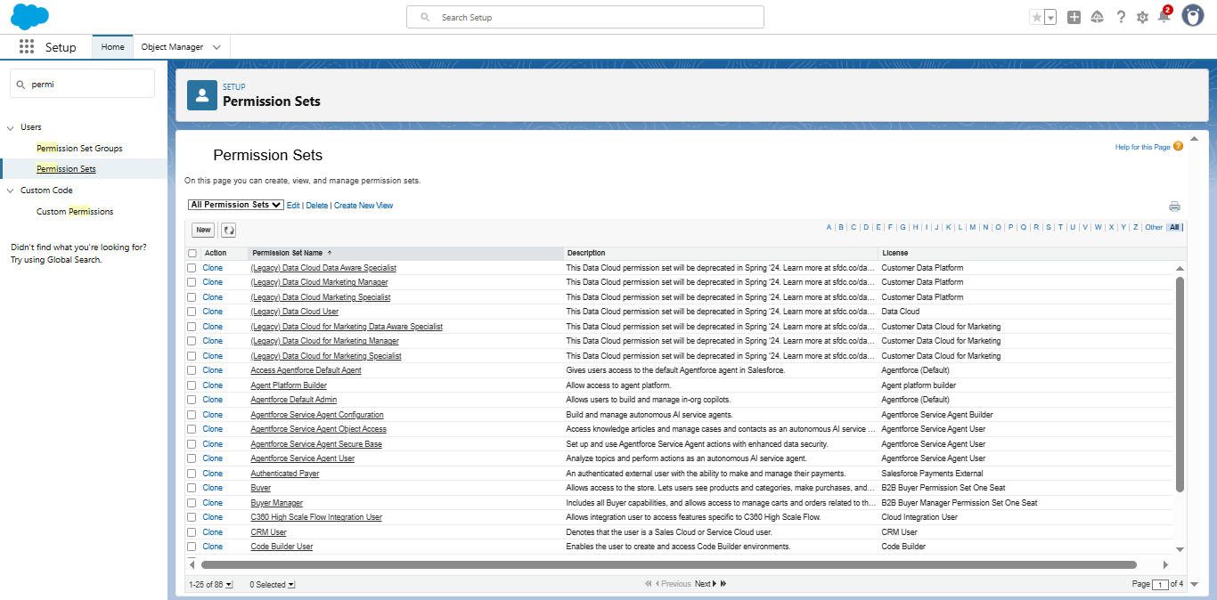

* **Create a Trigger Handler Class**

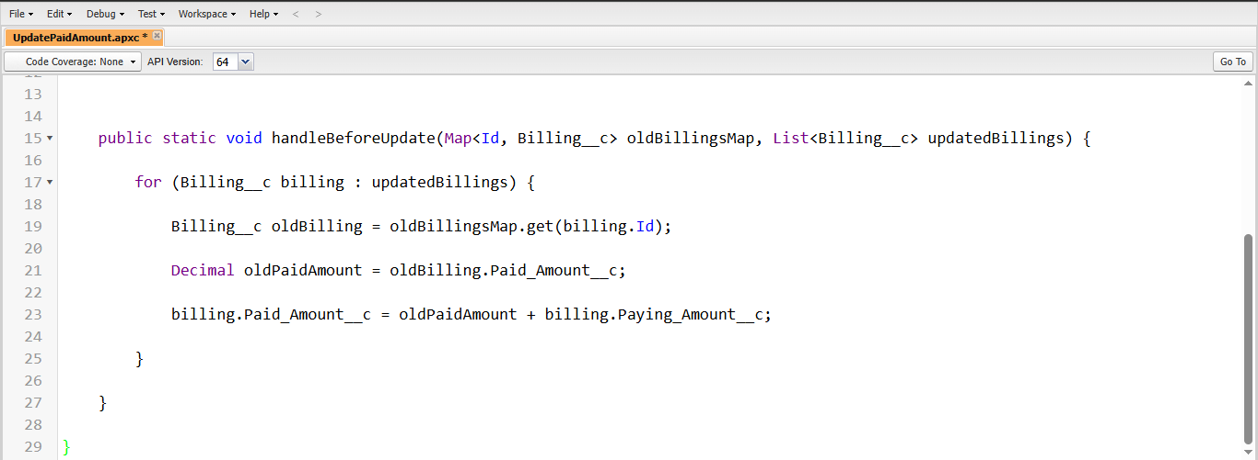

* **Create a Trigger**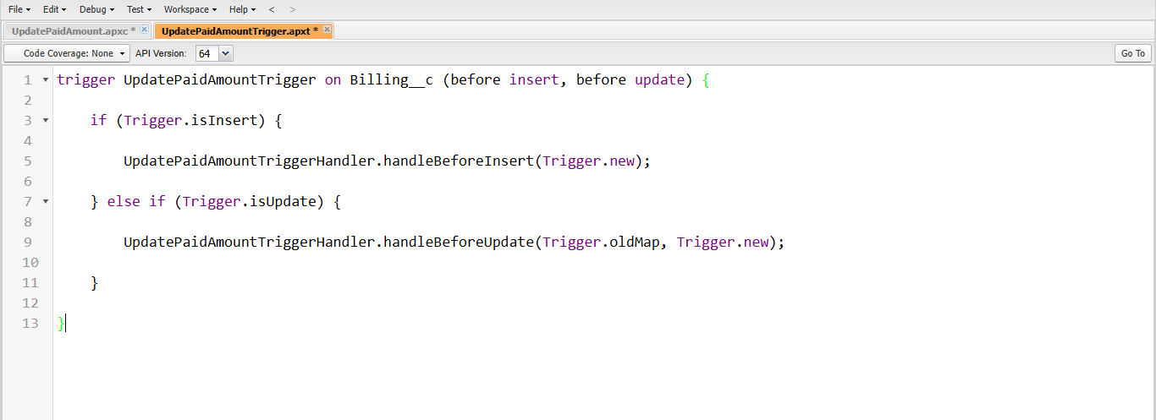
* **Create a Record**

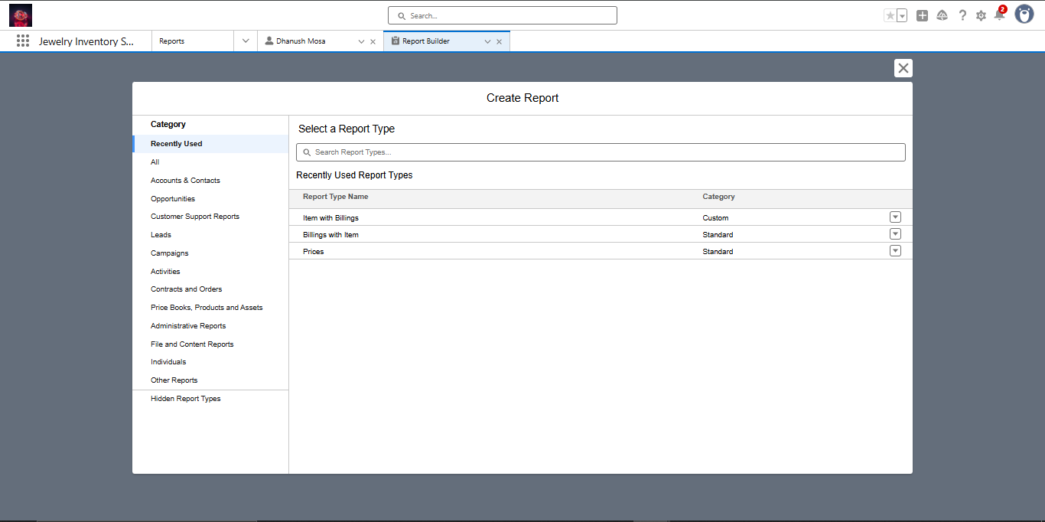

* **View a Record**

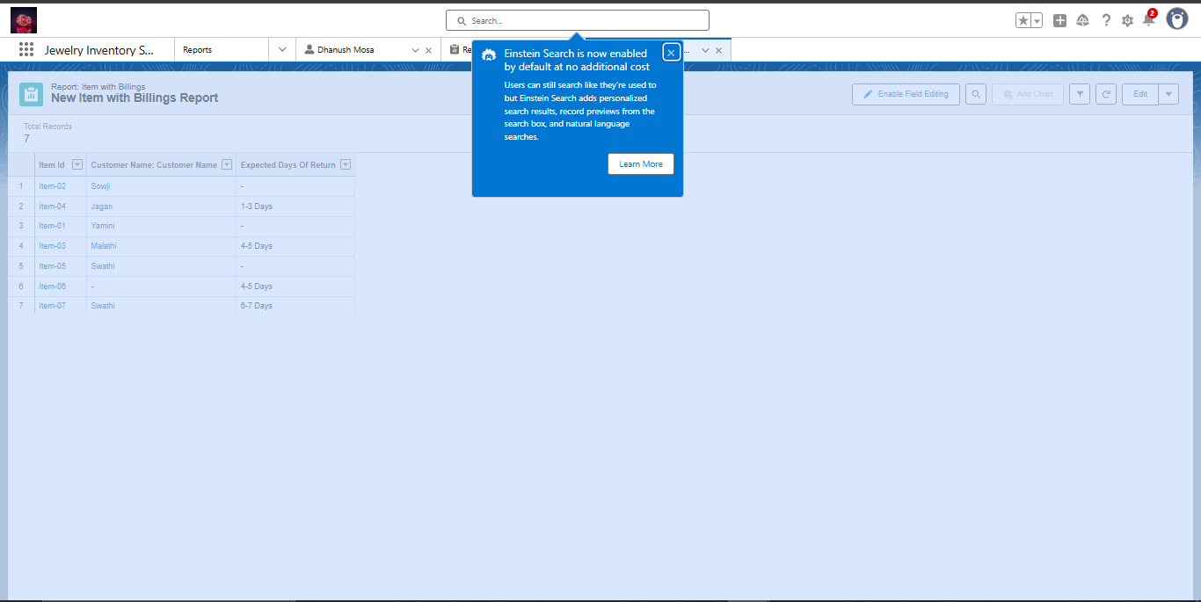

* **Create Reports**

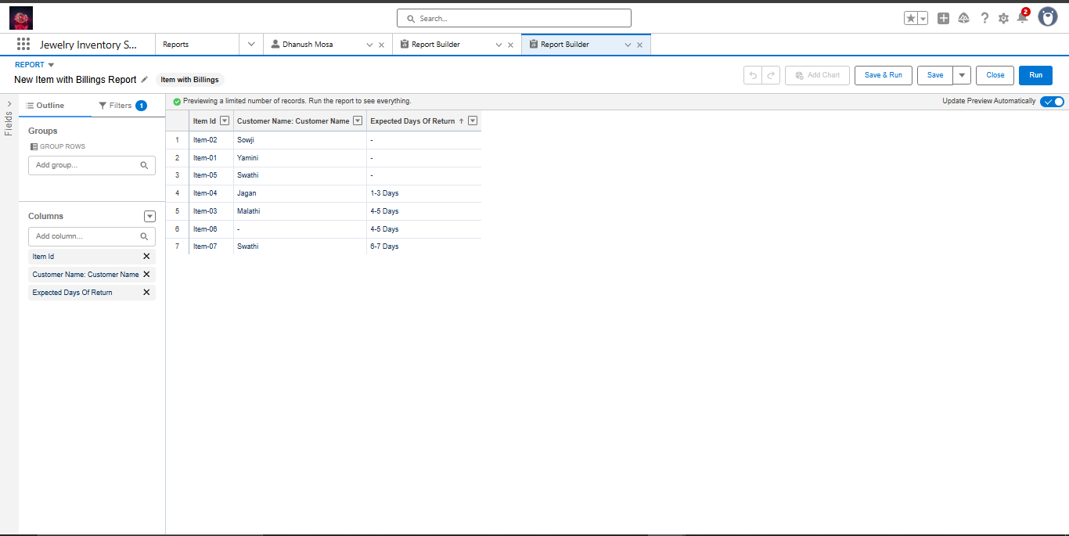

* **Create Dashboards**

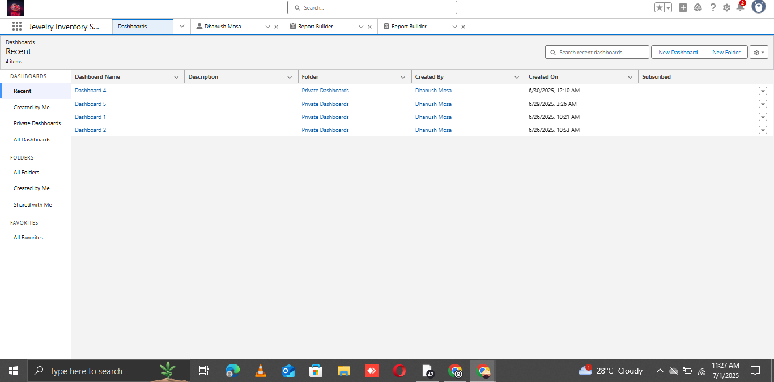

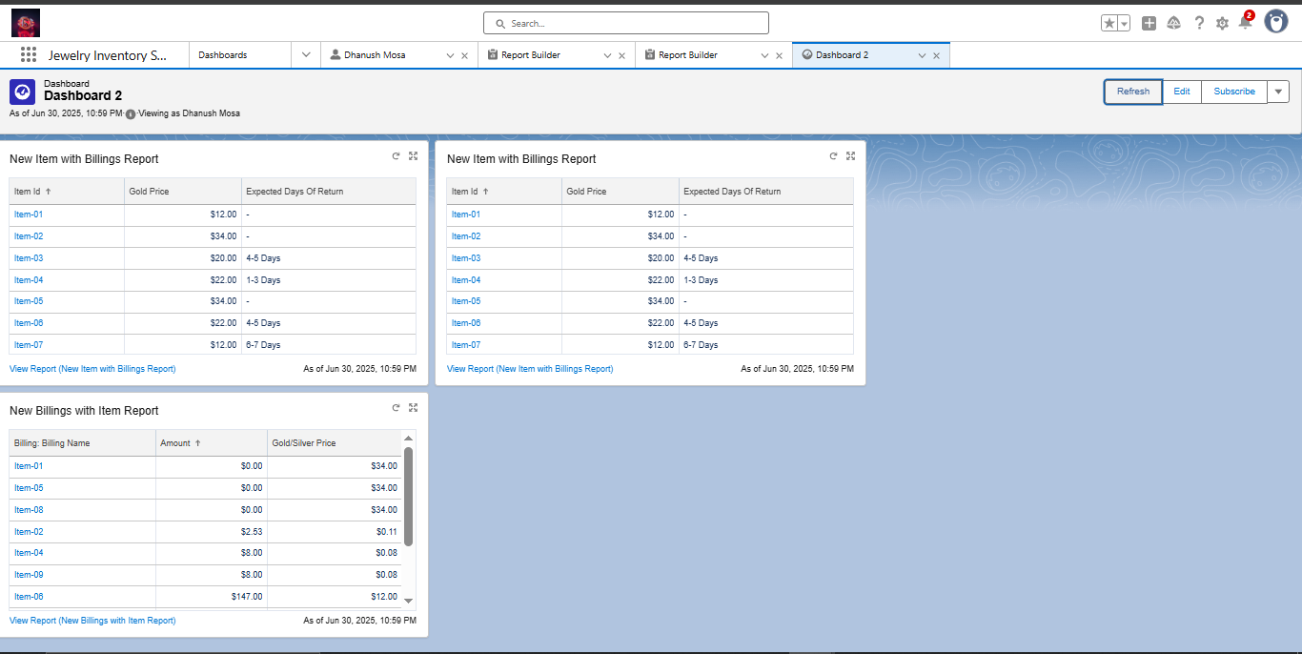

* **Create Flow**

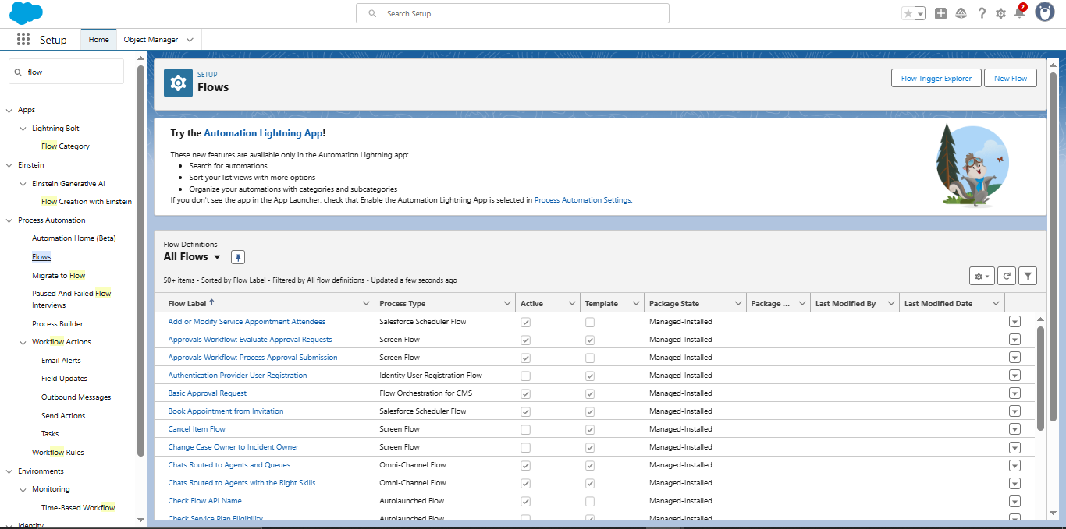

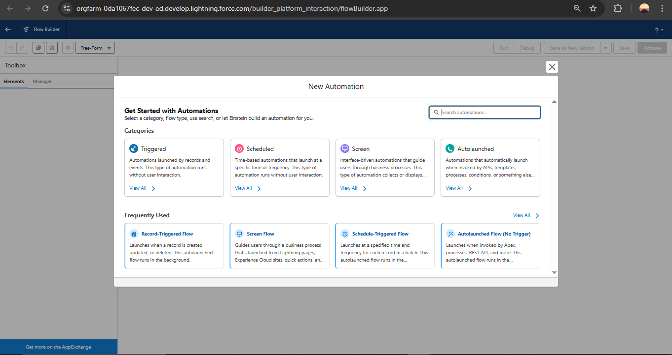

**ADVANTAGES:**

**Know Your Customers Better: It remembers everything about your customers – what they bought, what they like, their birthdays, and even their spouse's anniversary. This helps you treat them like VIPs.**

**Sell More Smartly: Instead of guessing, you know exactly who to offer what. Send a birthday discount for diamonds to someone who loves diamonds! This means more sales for you.**

**Keep Customers Coming Back: When you remember their special occasions and preferences, customers feel special. This makes them loyal and they'll choose your store again and again.**

**Run Your Store Smoother: It helps track inventory, orders, and repairs. Less confusion, more organized work.**

**Make Better Decisions: See what's selling well and what customers are asking for. This helps you pick the right jewelry to buy for your store.**

**DISADVANTAGES:**

**Can Be Expensive: Buying and setting up a CRM can cost a good chunk of money upfront, plus there might be ongoing fees.**

**Takes Time to Learn: Your team will need training to use it properly. It's like learning a new skill, and it takes time and effort.**

**Needs Good Data: If you put in wrong or incomplete information, the CRM won't be very helpful. "Garbage in, garbage out," as they say!**

**Might Feel Less Personal (if you're not careful): While it helps personalize, relying too much on technology can make interactions feel less human if you don't balance it with real warmth and connection.**

**Security Worries: Customer information is sensitive. You need to make sure the CRM is super secure to protect their data from hackers.**

## **CONCLUSION :**

**For jewelers, a CRM application is a powerful asset. It allows you to deeply understand customer preferences and purchase histories, enabling personalized service that builds stronger loyalty. This translates into smarter, more targeted marketing and increased sales opportunities. Beyond customer relationships, a CRM streamlines inventory and order management, boosting overall efficiency.**

**While there's an initial investment and a learning curve for your team, the ability to make data-driven decisions and offer exceptional service makes it worthwhile. Ultimately, a CRM helps your jewelry business not just manage, but truly flourish, ensuring every customer interaction is as precious as the jewels you sell.**

## **Future scope of CRM for Jewelers: Simpler Insights**

**The future of CRM for jewelry stores is about making things even *smarter* and more *personal* for your customers. Think of it as your super-powered assistant getting even better!**

### **Key Trends:**

* **Mind-Reading Recommendations: CRMs will get so good at understanding what customers like that they'll suggest the perfect piece *before* the customer even knows they want it. This means using AI to look at past buys, online Browse (even virtual try-ons!), and special dates to offer highly personalized jewelry.**
* **Smarter Automation: Many tasks you do now will be handled by the CRM using AI. Imagine it automatically updating customer info, suggesting who to follow up with, or even answering simple questions through a chatbot. This frees up your team to focus on meaningful interactions.**
* **Seamless Shopping: Whether a customer is looking online, trying on a piece virtually, or stepping into your store, the CRM will know their journey. This creates a smooth, connected experience no matter how they interact with your brand.**
* **Virtual Try-On & Showrooms: Expect CRMs to link up even better with AR/VR tools. Customers can "try on" jewelry with amazing realism, and the CRM will learn from what they liked or disliked, making future suggestions even better.**
* **Proof of Origin: While not directly CRM, linking to blockchain (a secure digital record) could let your CRM instantly show a gem's full history and ethical sourcing to a customer, building huge trust.**

**GitHub Link:**

**Demo Video Link:**